**Why Membership?**

Membership is significant for a number of reasons. It gives the individual believer the opportunity to be involved in the decision-making processes of the church as well as leadership responsibilities. It provides a structured means by which deviations in doctrine and practice can be addressed by Church leadership in a Biblical authorised manner. Most importantly it signifies that together we commit to each other. That we will, in God’s grace and strength, support, care, encourage and love each other through life’s joys and trials, because this is our spiritual family, our spiritual home.

**What are members responsibilities?**

Anyone seeking membership should sense they are aligned with the general direction the church. They are wanting to be committed to the life, ministry and values of this church. As someone who has repented of their sin and confessed their faith in the Lord Jesus Christ they have a new identity as a Beloved Child of God. Invited into the benefits of the covenant relationship they live out their new identity in Kingdom Responsibilities. Some of these Kingdom Responsibilities include a commitment to the church family. Church members agree:

* Faithful obedience to Jesus Christ in on-going discipleship
* To be an active participant in church life and use their gifts to serve others. This may include participation in the larger gatherings; growth groups; other small Christian communities and personal support of members and attenders
* With the emphasis, direction and values of the church and to support the church leadership
* To try to build healthy and respectful relationships throughout the church family
* To financially contribute to the Kingdom of God including the church
* To pray about church direction and participate in Church Members’ meetings where possible
* Seek sustainable ways to participate in the mission of Jesus in this world.

**Foundations of Churches of Christ**

**Our identity**

*We are Churches of Christ Hervey Bay.*

Our identity, existence and purpose as an organisation is found in Jesus Christ as revealed in the scriptures. Jesus Christ is the head of this Church.

**Historical foundations**

As we read in the Acts of the Apostles, the Christian Church was called into existance around AD 30. Since that time there have been many struggles and issues. In the early part of the 16th century, Martin Luther protested against practices that had grown up in the Catholic Church. The Bible was printed in the language of the common man for the first time and a new understanding of being ‘justified by faith’ articulated.

Later John Calvin stressed the divine sovereignty of God and John Wesley agitated for more spirituality in the churches. Around these great movements of God, great denominations grew; but so did divisive walls. As time went on, more and more splits occurred as people claimed authority and insight. By the 19th century there were hundreds of ‘denominations’ and groups claiming to be the true church.

In the midst of all this, a movement emerged that centred on Christ and the Bible. The spirit of God was moving in the lives of many people. They were unknown to one another, yet shared a common sense that all this divisiveness was wrong – Christ had founded one church: one body with one mission. Their collective heart was to call on all Christians to unite on the basis of restoring New Testament faith and practices. There was a conviction that through this reformation, the church would be restored and reborn into what God intended.

Churches of Christ Hervey Bay is an afiliated church with Churches of Christ in Queensland, which is in turn part of this “restoration movement” which began around 1800 in the USA. Believers from various denominations began to meet together with the goal of attempting to reproduce the essence of the church as presented in the New Testament. They saw themselves as a movement and had no thought of founding another denomination.

They still had theological differences, but they insisted that this was acceptable as long as all beliefs could be supported from the Scriptures. A shared principle of the Churches of Christ movement was the saying from Saint Augustine, used by John Wesley and other Christian leaders: “in essentials, unity; in opinions, liberty; in all things, love”.

**Foundational principles**

While Churches of Christ do not have a set creed or written statement of faith, the following principles have been foundational to the movement since the beginning (*early catchcries are in italics):*

 Acknowledge Jesus as the only head of the church

|  |  |
| --- | --- |
| ooxWord://word/media/image3.bin | Exclude sectarian names, using the title of Christian only.  *Not the only Christians, but Christians only.* |

|  |  |
| --- | --- |
| ooxWord://word/media/image4.bin | Use the New Testament as the only rule of faith and practice, not man-made creeds.  *No creed but Christ* |

 Promote the rights to private judgement, liberty of conscience and mutual responsibility.

*Where the Bible speaks, we speak; where the Bible is silent, we are silent; in all things grace and liberty*

 Faith is available to anyone who chooses to believe

 Make Christian character the only real test of membership and fellowship

 Practise believer’s baptism

|  |  |
| --- | --- |
| ooxWord://word/media/image9.bin | Observe the Lord’s Supper weekly.  *All who love the Lord are welcome at the Lord’s table* |

 Establish congregational government, plurality of elders, the rights of lay leaders to lead, and congregational cooperation and support.

*The priesthood of all believers*

 Work towards the union of all followers of Christ so that the world will believe.

**Our mission**

When asked what the greatest commandment was, Jesus responded as follows:

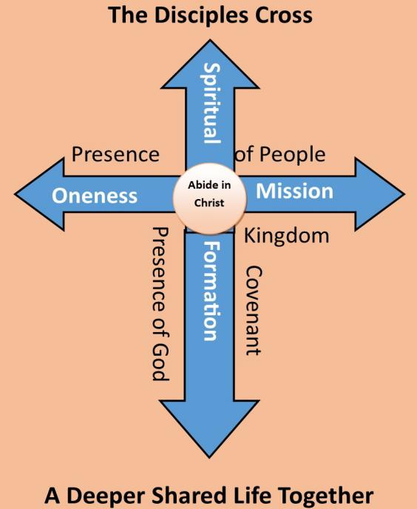

Jesus said, “‘Love the Lord your God with all your passion and prayer and intelligence.’ This is the most important, the first on any list. But there is a second to set alongside it: ‘Love others as well as you love yourself.’ These two commands are pegs; everything in God’s Law and the Prophets hangs from them.”

(from Matthew 22:37-40 in The Message).

Jesus, undeterred, went right ahead and gave his charge: “God authorized and commanded me to commission you: Go out and train everyone you meet, far and near, in this way of life, marking them by baptism in the threefold name: Father, Son, and Holy Spirit. Then instruct them in the practice of all I have commanded you. I’ll be with you as you do this, day after day after day, right up to the end of the age.”

(from Matthew 28:18-20 in The Message).

The Disciples Cross helps us think this through. As we abide in Christ (John 15); through various spiritual practices we can be formed into Jesus. Spiritual Formation is a primary focus of this church and not an assumed by product. Loving the Lord your God with all your heart, mind and soul (passion, prayer and intelligence) is the primary command. But so is “Loving one another like yourself”. He also says that that by this love for one another, all will know you are my disciples (John 13:35). This, then leads to how we love and serve our community in mission: making disciples and seeing His Kingdom come and will be done on this Earth as it is in Heaven (Matt 6:10) serving and reaching our community in mission.

**Values**

As our name implies, ‘Churches of Christ’ was founded on the teachings and values of Jesus Christ who calls on every one of us to individually be a light in the place we are in, and to collectively be the light of the world through the expression of love.

He calls upon us to be united in this effort and to work together as one body, and this is not just something we do, but rather a way of life. Flowing from this understanding of who we are and what we stand for.

Several words and phrases sum up our aspirational and lived values: Jesus Centred; Safe

**Expressions and Practice**

We live with three life goals:

1. To be with Jesus
2. To become like Jesus
3. To do the things that Jesus did

This is ultimately live out in a gentle discipline called a “Rule of Life”. An example called BELLSS is found below.

**Bless** (Generous)- We seek to bless others inside and outside our own fellowship of believers each week.

**Eat** (Hospitable) – We seek to eat with others both inside and outside our fellowship each week.

**Listen** (Spirit Led) – We seek a weekly practice of silent listening to the Spirit; daily reflection and regular journaling.

**Learn** (Christlike) – We seek to learn Jesus by meeting regularly with others in growth groups to delve deeper; read something from the Old Testament, something from the New Testament and something else encouraging about Jesus.

**Sent** (Mission) – We seek to live a life where we expect God to already be at work in the world and in the people we meet. We seek to meet people real and felt needs, live questionable lives and be ready with gentle and respectful answers to the questions that arise.

**Sabbath** (Centred) – We seek a healthy rhythm of engagement with people and disengagement from people to be with God. Each week to stop, rest, delight and contemplate.

**Safe:**

**Code of Honour**

**Caring** (for the little guy) – Love expressed to everyone but following in the way of Jesus especially for the vulnerable, needy and poor.   
**Committed** (ring finger) – That we commit to sticking to each other even in the tough times and to doing our best for God’s glory.   
**Respectful** (middle finger) – We will speak to each other in encouraging and honouring ways. We will treat each other as beloved brothers and sisters.  
**Responsible** (pointer finger)- That I will take responsibility for my actions, behaviours, emotions and attitudes. If I am not doing will I will ask for help and support. When I point the finger at someone else three fingers are pointing at me.   
**Fun** – If it is not fun for all it is not fun at all. We will attempt to keep our sense of humour but we will also seek to resolve conflict quickly and in healthy ways.

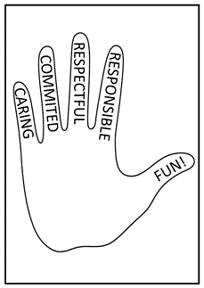

**Growth Groups**

Growth groups form an important part of our apprenticeship. They are a place we grow close to each other through fellowship, spiritual formation, scripture integration and mission.

**Brigades/COACH and other Ministries**

We will over time work with members and discern God’s direction to create ministries that meet specific needs including Brigades designed to disciple young people. Another opportunity is through COACH a community mentoring program. Other ministries may reach out to the community and seek to meet people’s real and felt needs (Matt 25:31-46). Possibly some of these may include:

* School Breakfast Club
* Initiatives to alleviate homelessness.
* Sunbird Junior School

|  |  |  |  |
| --- | --- | --- | --- |
| **Validity – Why we exist?** | | | |
| **Purpose** | | **Mission** | |
| Because for humans to thrive we need an apprenticeship to Jesus and this is best done in community | | To be a people formed into Jesus and extending His love | |
| **Values – Who are we?** | | **Vision – What we want?** | |
| Jesus Centred Everyone Matters Safe Authentic | | To be a community of faithful Jesus followers experiencing a Deeper Shared Life Together and inviting others to join us | |
| Strategic Priorities – Key Performance Indicators | | | |
| **Strategic Goals** | **Critical Success Factors** | | **Vehicles** |
| 1. **Emotionally Healthy Spirituality**   “I’ve been with Jesus”   1. **Supportive Caring Relationships**  “I feel valued”      1. **Biblically Mature Theology**   “I am becoming like Jesus”     1. **Loving Effective Mission** “I have meaning, doing what Jesus did” | * Safe, invitational opportunities for everyone to play with the practices of Jesus * Cultivating presence of God in corporate worship * Explore establishment of formation hub * Train leaders to run growth groups * Develop a culture of inclusion and welcome * Develop a culture of safe vulnerability      * Teach Jesus ultimate revelation of God as revealed in the scriptures * Experience observable growth in knowing and becoming like Jesus * Support people in **their** mission * Empower the church to participate and grow “Everyone gets to play” * Explore Empowered Missional Community * Foster partnerships with School Chaplains | | * Retreat days * AM Coffee * Creating room in Sunday services for silence, reflection and teaching      * Code of Honour * Morning Tea * 5th Sunday Lunch * Growth Groups * Demonstrate healthy relationships * Sunday teaching * Growth groups * Individual bible reading/plan      * BDC Huddles * Build team for EMC with vision casting * Establish EMC * Rhythm of Life * Brigades |

**Come Join Us**

We invite you to pray about your commitment to formally join us. Becoming a member does mean you are making a commitment to us as a people and this expression of the church – Hervey Bay Church of Christ. It also means you can vote on proposals, elect elders and participate in important decisions like calling pastors or future church direction. If you wish to become a member please fill in the form below.

As a beloved Child of God I am ready to live out my Kingdom Responsibilities by being a committed member of Hervey Bay Church of Christ. I accept the challenge of Church Membership and submit my application for membership to the church leadership.

Name:______________________________________________________

Phone: M:_______________________ H:__________________________

Email:_______________________________________________________

Address:_____________________________________________________

____________________________________________________________

Signed:____________________________________ Date: _____________