Group Discernment

The flower of discernment has many petals.

This short training program has been written with the Elders at Hervey Bay Church of Christ in mind and presented at our first Elders retreat in February 2020. The context is that governance of Hervey Bay Church of Christ has been from Head Office, Brisbane after a church split 5 years ago. The church is essentially a restart. The church has some money to pay wages (for a few years) and a building right in the centre of town. We plan to form an interim Eldership and work toward reconstituting the church next year. The Church currently has a regular Sunday attendance of approximately 30 who are committed to growing into Christ; serving their community in mission and loving each other.

Few churches have a clear process for hearing from God. Many groups rely entirely on “secular” models of decision making. For others the group or group leader is so unhealthy that although they may have practices of hearing God’s voice it may feel unsafe to express a differing opinion from the one proposed by the key leader. These sessions will hopefully provide a healthier “third” way. Given our context, now seems like a great time to start to learn to live and lead out of a place of listening surrender to God’s will.

To begin the listening process of discerning God’s will, it is necessary to establish clear protocols and processes offering a shared vocabulary, values and vehicles to achieve the first part of the vision: Becoming a Covenant Community, Committed to God Communication.

A picture of discernment with its many parts will be pictured as petals of a flower with parts being added as we go.

**What do you think discernment is? Discuss**

**Below is a number of quotes about discernment.**

*Discernment includes the commitment to consider all pertinent factual data and to honour inner dynamics such as consolation and desolation; fear and resistance; desire and calling.[1]*

*Discernment then is the process of intentionally becoming aware of how God is present, active and calling us as individuals and communities so that we can respond with increasingly greater faithfulness[2]*

*The purpose and goal of spiritual discernment is knowing and doing God’s will.[3]*

*God’s will: nothing more, nothing less, nothing else.[4]*

*So, the thoughts and feelings in the mind and spirit of one who is surrendered to God should be treated as if God were walking through one’s personality with a candle directing one’s attention to things one after the other.[5]*

*Discernment, in the most general sense, is the capacity to recognise and respond to the presence and the activity of God - both in the ordinary moments and in the larger decisions of our lives.[6]*

*Don’t copy the behavior and customs of this world, but let God transform you into a new person by changing the way you think. Then you will learn to know God’s will for you, which is good and pleasing and perfect.[7]*

**What are some ideas and themes that stick out for you?**

**______________________________________________________________________________________________________________________________________________________________________________________________________________________________________________________________________________________________________________________________________________________________________________________________________________________________**

**Commitment and Covenant**

No group can operate without a covenant, written or unwritten, it will emerge. Without a written covenant to refer to, groups or Elders can be at risk of devolving into power struggles, unhealthy patterns of silence, triangulation and manipulation. Barton says, *“A commitment to leadership discernment requires cultivating an environment in which it is safe for people to speak from their heart and soul and not just from their mind.”[8]*  Barton has suggested a number of categories and I have worked them into a proven format.

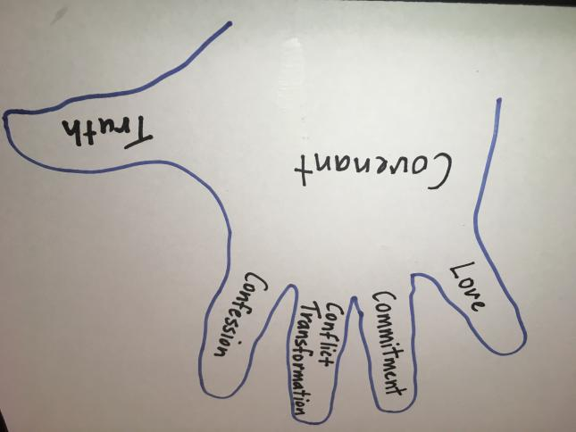

The advantage of this format is it is easily remembered; easily referred to and carried wherever you go.

**Practicing Love:** (Looking after the little guy - the vulnerable).

Really listening to each other; praying for each other; being kind in word and deed; valuing each other’s contributions and gifts; particularly when it is difficult to do so.[9] This includes confidentiality, what is said in the group stays in the group, except when we are ready to share conclusions and outcomes with the wider church and community. Normal limitations to confidentiality apply but your thoughts, heart, and deepest longings you share with the Elders will be held in safe confidence.

John 13:34-35; Proverbs 11:13

**Commitment:** (Ring finger - symbol of commitment).

We offer an invitation to *“Our commitment to stability is that we commit to staying together until together we discern a need for change.”[10]* Given our current situationwe need to discuss what our commitment looks like. What are you willing to commit to? When and how will we review this?

1 John 4:20; Acts 2:42

**Conflict Transformation:** (Middle finger - Am I giving you the finger or pointing it at my heart?)

What is the issue beneath the presenting issue? Can we get to the heart of the issue? In the presence of Jesus *“…we affirm that conflict can be a catalyst for needed growth and transformation for everyone involved if we are willing to engage it as such.”[11]*

Matthew 18:15-22; Proverbs 15:1; Matthew 5:9, 24; Philippians 2:4; James 1:2-4,19; Matthew 7:1-29.

**Confession:** (Pointer finger, am I taking responsibility for my actions or blaming others?)

Seeing something that went wrong in attitude or action and calling it for what it is; how it affects the group and/or my presence/behaviour in the group; seek to understand the inner dynamics that caused this behaviour.[12] “*Healthy functioning in community is dependant not only on our growing self- awareness but also our ability to take responsibility for the quality of our presence and action in the group by acknowledging and confessing sin.”[13]*

James 5:16; 1 John 1:9; Proverbs 28:13; Psalms 32:1-6; Romans 10:9-10; James 4:8.

**Truth Telling:** (Thumbs up - being honest is A OK).

When trust has been built telling the truth in love is valued and respected. Truth is not spun or diluted. People are thanked and appreciated because they took a risk to speak their truth. Everyone is given opportunity to speak. *“Thank you for taking the time to tell us the truth. Truth telling is hard and you have served us by bringing us this truth. Even though this is hard to hear, we are truly grateful.”[14]*

Ephesians 4:14-16, 25; Zachariah 8:16; Colossians 3:9-10; Proverbs 14:25; Matthew 5:37.

**Questions:**

Are there any areas that make you feel uncomfortable?

Have we missed something? Could this be worked in or do we need another point?

**Making the Covenant Work**

Each person in the group needs to be able to call others back to covenant when it is being broken. A brief clarifying conversation is had; apologies may be sought and a way of interacting reiterated or reestablished.

Are you willing to sign the covenant as a symbol of your commitment to it?

**Notes:**

**Spiritual Practices (rule of life)**

In Jesus’ ministry he lived consistent and regular patterns of engagement with people and disengagement of rest and refreshment. (Matt 11:28) Jesus’ lifestyle was characterised by times of ministry with the crowds, times with the disciples and times of prayer by himself. The disciples were prepared for public ministry as they spent time with Him and practiced prayer with Him. They were formed into Him; that is became like Him.

No group’s spirituality or maturity can exceed the spirituality and maturity of the group members. For this reason, it is vital that Elders grow their own spiritual life through regular practices. Jesus wants to form us into Himself. Like the disciples we also need to spend time with Him through various regular spiritual practices. Each of us needs to grow deeper, grow our own soul. *“The soul is a person’s core self or spiritual center where the physical, mental and emotional life come together as one in relation of God. This is the part of each of us that our leadership group needs most.”[15]*

*“In a community that values transformation, anyone in leadership should be able to articulate a regular pattern of spiritual practices attitudes and behaviors that keep them open and available to God. They should be just as clear about their spiritual rhythms as they are about their eating, sleeping and exercise habits.”[16]*

Each member should develop their own “Rule of Life” (regular practice) that can help them to spiritually grow and develop their “ear” to hear the voice of God. After suggesting that a “Rule” is like a trellis for a vine to grow on Peter Scazzero says, *“A Rule of Life, very simply, is an intentional, conscious plan to keep God at the centre of everything we do. It provides guidelines to help us continually remember God as the Source of our lives. It includes our unique combination of spiritual practices that provide structure and direction for us to intentionally pay attention and remember God in everything we do. The starting point and foundation of any Rule is a desire to be with God and to love him.”[17]*

As Brent Bill points out these practices should lead us to a place where we can learn and listen both to the Spirit and wisdom of Jesus formed in us. This is what he calls our sacred compass “*Following our sacred compass leads us to a place where we learn from God in daily and in the lifelong. This place is one of seeking and sensing God*….*In a grace filled way, our compass invites us into a life of continuous experiences of God and of spiritual transformation. As we move toward divine guidance, we joyfully behold the face of a loving God gazing back at us*.”[18]

Ruth Haley Barton states*, “Discernment requires first of all, that we are able to discern matters of our own heart. A leader cannot be discerning about external matters if they are not able to discern what is true and false within themselves. They become dangerous in the leadership setting because they are subject to hidden motives and defense mechanisms that are unknown even to themselves.”[19]*

You probably won’t settle on a “Rule of Life” on this weekend but maybe thinking through some parts may be a starting place for further conversation. Have a look at our Disciples Cross that has some Spiritual Practices listed. We are somewhat familiar with these as we have explored them together.

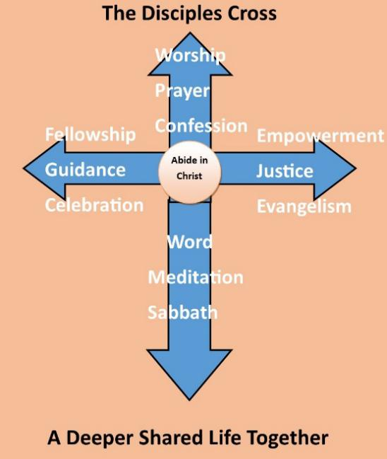 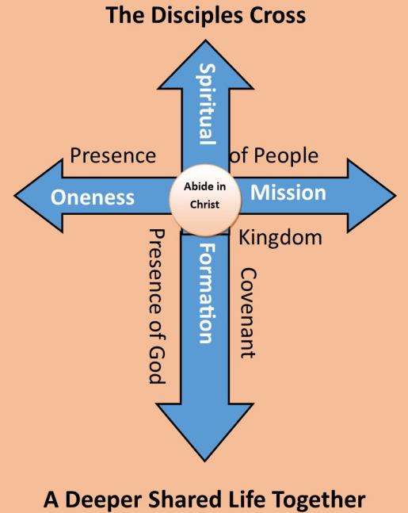

The vertical axis of the cross represents our relationship and interaction with God and the horizontal our interaction with people. In the vertical axis there are gifts that God offers us through his Holy Spirit and offerings we give back to Him in response. The right-hand horizontal points us in empowered mission to a broken and hurting world. It is the great commission (Matthew 28:18-20 and Matthew 25:31-46). The left-hand horizontal axis calls the faith community to love one another; live in unity, that they might be one (John 13:34-35; John 17; Romans 12:10; 13:8).

It will take a couple of years to develop a Rule of Life. But it starts with a first step and then a next step. Consider what spiritual practices are currently effective in your day/week/year.What spiritual practices have been beneficial in the past and what are you wanting to develop? Can you identify a pattern that is working? Can you see a pattern forming? Allow time for this to develop. Consider the context of Engagement or Abstinence? Of Personal or Corporate? Consider this table or create your own.

**Notes:**

**Developing a “Rule of Life.”[20]**

An example can be found below. We all have a rule of life deliberate or otherwise written or just accepted and written rules can take many forms. Below is just one partially filled in Rule of Life.

|  |  |  |  |  |  |  |
| --- | --- | --- | --- | --- | --- | --- |
| **Rhythm** | **Daily** | **Weekly/**  **fortnightly** | **Monthly** | **Quarterly** | **Yearly** | **As needed** |
| **Prayers** | Each  Morning using pray as you go |  |  |  |  |  |
| **Mediation** |  | meditation group |  |  |  |  |
| **Generosity** |  |  |  |  |  |  |
| **Scripture** |  |  |  |  |  |  |
| **Scripture** |  |  |  |  |  |  |
| **Sabbath** |  | Each Saturday |  | Short holiday | Longer holiday |  |
| **Fellowship** |  |  |  |  |  |  |
| **Fasting** |  |  |  |  |  |  |
| **Simplicity** |  |  |  |  |  |  |
| **Discipling** |  |  |  |  |  |  |
| **Solitude** |  |  |  |  |  |  |
| **Other** |  |  |  |  |  |  |

**Meeting Structure**

*“What needs to die in me/us in order for God’s gifts and direction to find room in our lives.”[21]*

What will help us to put aside our own egos and opinions?

If spiritual practices beyond opening and closing prayers are not practiced as a part of every meeting they may seem strange or forced when we try them. Barton suggests starting every meeting with a time of silence 10-20 minutes in length; pray the fixed hour of prayer closest to your meeting time;[22] practice Lectio Divina with scripture reading; read/pray Psalm 131 (prayer of humble trust).[23] Other practices may grow and develop but using lectionary readings takes the pressure off having to deliver a devotion and instead invites everybody into spiritual practices and stances that help us be receptive to the gentle voice of the Spirit.

Our prayer could be this:

*Good and loving God, our source of love and light -  
Thank you for bringing us together today  
in a spirit of generosity.  
May we honor one another  
by keeping an open mind.  
May we voice our truth  
and listen with an open heart.**May we discern your will  
to unite in fruitful outcome.  
We ask for your wisdom and grace,  
to use our talents for the betterment of others.  
With gratitude, we offer this prayer in your name.[24]*

**Values (touchstones)**

Developing a set of robust values is vital for healthy groups. Values are the guiding principles that we first turn to in any decision. Although a group’s values are often aspirational, ideally they are bedded in a true sense that this is, “who we are”. To go against those values would be to violate our very nature as a Covenant Community.

Jeff Allen suggests asking these questions when forming values:

* *Do our values describe the way in which our covenant community behaves in its relationships with one another?*
* *Do our values reveal and reflect the nature or our heavenly Father’s heart?*
* *Do our values express relational behaviour that is based in grace?*[25]

As we begin to discern important matters our values become touchstones that we go back to.[26] Does this sit comfortably with our values or does this feel like a violation of those values?

Values should be few enough in number to be easily memorable, words or statements that the whole group affirms and can turn to as guiding principles.

What do you think are the values we live by? Take a few minutes to think and we will discuss.

____________________________________________________________________________________________________________________________________________________________________________________________________________________________________________________________________________________

_____________________________________________________________________

Are there values we would like to live into? Take a few minutes and we will discuss.

____________________________________________________________________________________________________________________________________________________________________________________________________________________________________________________________________________________

**Consultation and Data Gathering**

Discernment is not doing away with our brain. We don’t ignore everything we know about decision making and ask God to direct audibly. As Barton points out we still need to consult those directly affected and anyone involved.[27] We also should gather whatever relevant information we need to make a good decision. Finances, costs in time and energy, hoped for outcomes, proven record elsewhere, any other implications should all be laid out for consideration and discussion.

**Framing the Question**

Are we asking the right question? In my opinion, this question is not asked anywhere near as often as it should be. Much time can be wasted because the question has not been framed well. If we are to discern well, then the question under consideration, the issue I want to hear from God about, must be clear.

A few years ago our Senior Pastor had been approached by some members concerned that we didn’t have many people in ‘home groups’. He raised the question with the Elders “How do we get more people to participate in home groups? A tired and frustrated Eldership wrestled with the question to no avail. Only later did I reflect that we had numerous types of small groups gathered around mission and discipleship. We were asking the wrong question.

*“A subject for discernment should be clearly stated or agreed upon by the entire group. If guidance is needed, the question becomes, “God, what are you guiding me/us to do?” If the question is to be tested it is a yes or no question.”[28]*

What sorts of things do you think should be discerned?

_______________________________________________________________________________________________________________________________________________________________________________________________________________

Do we already have agreement? Does this sit in or outside our values?

What other relevant questions could be asked?

____________________________________________________________________________________________________________________________________________________________________________________________________________________________________________________________________________________

Clarifying the question will mean stating the guiding principle. In Acts 1:21-26 the guiding principle to replace Judas “with someone who was with them from Jesus baptism and witness to his resurrection.” Two names were submitted and Matthias chosen.[29]

**Discussion**

Once all of the data has been gathered; the consultation summarised; the question at hand clarified; a discussion of points of view needs to be had. It may become clear that the proposal as it stands does not fit our values. Or it could be that strong, unexpected objections have come out of the consultation. All these need to be discussed. A simple consensus may emerge about many issues but on others there may be disagreements. Disagreements at this stage are helpful to the group in that they are able to practice listening to understand rather than listening to reply. The discussion may also be helpful in defining the guiding principle. We are not trying to convince others to our side but to understand the points in full. This means that somebody will need to have done the hard work of really understanding the issues in advance. Discernment shouldn’t proceed to the next step if the Elders are not confident that they have a thorough understanding of the options.

**Roles**

At this point it is important to clarify some roles. Somebody needs to be the facilitator of the discernment process. This person facilitates the conversation and the discernment process. They may suggest: that discussion start/end; times of silence; prayer; ask for feedback from the group; seek from the group a consensus; speak last. The facilitator also needs to clarify with the group how to proceed. Not everything needs to be discerned further. There may be whole hearted agreement on an issue. On the other hand two viable options may have emerged. Other options may have emerged out of the conversation that need further explorations and clarification.

**Process of Indifference**

*“God's will: nothing more; nothing less; nothing else."[30]*

*“Am I indifferent to everything but God’s will?”[31]*

*“Cultivate indifference.”[32]*

If a topicneeds further discernment ask:

Am I self aware enough to name my prejudices and assumptions to the group?[33]

Do I need to die to something in order to be free to listen?[34]

The facilitator will need to “test for indifference” and seek from each of the Elders, if the are in a place of “indifference”? They may do this by asking “Are you indifferent to everything but God’s will?” Truth telling will allow people to speak their truth without pressure. They may have good reasons of investment for struggling to come to a place of indifference. If the group thinks they are ready then the next phase can begin.

After seeking indifference and prayer a time of silence will be needed. This can be done together as a group but: listening to God can be difficult. Some will prefer to move around others remain very still. The group may prefer to be released to listen in there own way. Decide on a time to be back and silently move to a place where you can better “hear.”

**Feelings of Consolation and Desolation**

*“…tests the decision by allowing it to rest near the heart to determine whether it brings primarily feelings of consolation (a sense of peace and movement toward God) or desolation (distress and movement away from God).”[35]*

Colossians 3:12-17 Let the Peace of God rule in your hearts or be the umpire or guide.[36] This is God’s peace as experienced corporately in reference to guidance.

*“What do we mean when we talk of consolation and desolation? We are really only talking about our orientation, and the bottom line is this: which direction is our life taking us—toward God [consolation] or away from him [desolation]?*

*Here are some of the main symptoms of desolation and the most commonly experienced blessings of consolation.*

#### *Desolation*

* *turns us in on ourselves*
* *drives us down the spiral ever deeper into our own negative feelings*
* *cuts us off from community*
* *makes us want to give up on things that used to be important to us*
* *takes over our whole consciousness and crowds out our distant vision*
* *covers up all our landmarks*
* *drains us of energy*

#### *Consolation*

* *directs our focus outside and beyond ourselves*
* *lifts our hearts so that we can see the joys and sorrows of other people*
* *bonds us more closely to our human community*
* *generates new inspiration and ideas*
* *restores balance and refreshes our inner vision*
* *shows us where God is active in our lives and where he is leading us*
* *releases new energy in us”[37]*

How have you experienced feelings of Consolation and Desolation?

_________________________________________________________________________________________________________________________________________________________________________________________________________________________________________________________________________________________________________________________________________________________

**Coming to a Decision**

When the group returns the facilitator could ask the group for some feedback.

Are you willing to support the motion?

Answers may vary from yes; unsure; no and this is why. The feelings are meant to be a guide and not taken as authoritative “God said.”

From the answers a way forward needs to be decided. Yes is simple. No is simple. Unsure requires more time. The group could ask for more clarification or go separate ways in silence again.

John Dietzsch reminded me of a process he uses in such situations that appears to be based on a Jesuit approach of rigorous and vigorous mental examination:

1. *Rule a line down the middle of a page. Write pro on one side and con the other.*
2. *Propose going a certain way. For several days choose to live as if the decision has been made. As you go through your days, list what are the pros? What are the cons? What is interesting or what feelings emerge?*
3. *Propose the alternative direction. Repeat step 2.*
4. *Has a path become clear?*[38]

**Biblical Case Study**

Read Colossians 3:9-17

What are the themes that Paul addresses in this passage? In what ways do they relate to our conversation this weekend?

_________________________________________________________________________________________________________________________________________________________________________________________________________________________________________________________________________________________________________________________________________________________

Read Acts 15:1-35

What were the steps taken by the council at Jerusalem and how do they fit with the discernment process proposed?

_________________________________________________________________________________________________________________________________________________________________________________________________________________________________________________________________________________________________________________________________________________________

_______________________________________________________________________________________________________________________________________________________________________________________________________________

**Do and Learn**

The final step in any Discernment process is to do the will of God. What has been decided needs to be enacted. May we grow in Christ, love each other and serve our community in mission.

Finally I have read a little about discernment but have little experience. If you are willing we will make mistakes, learn and grow together. We can find way to refine our process and learn together to become better hearers and doers of God’s will.

**Bibliography**

Allen, Jeff. *Small Church on a Big Mission - Cultivating Missional Discipleship in Smaller Churches*. USA: 3DM Publishing, 2017.

Barton, Ruth Haley. *Pursuing God’s Will Together*. Downers Grove, Illinios: Inter-Varsity Press, US, 2012.

Bill, J. Brent. *Sacred Compass: the Way of Spiritual Discernment*. Brewster, MA: Paraclete Press, 2012.

“Discernment Prayer*s.*” Xavier University. Accessed November 18, 2019. <https://www.xavier.edu/jesuitresource/online-resources/prayer-index/discernment.>

Liebert, Elizabeth. *The Way of Discernment: Spiritual Practices for Decision Making*. Louisville, KY: Westminster John Knox Press, 2008.

Loyola Press. “Discernment: Consolation and Desolation.” Discernment: Consolation and Desolation. Loyola Press, January 10, 2017. Accessed November 18, 2019. <https://www.loyolapress.com/our-catholic-faith/ignatian-spirituality/discernment/discernment-consolation-and-desolation.>

Morris, Danny E. and Olsen, Charles M. *Discerning God’s Will Together: A Spiritual Practice for the Church.* Rowman and Littlefield Publishing, Lanham, Maryland, 2012

Sadler, Craig. “Discerning God’s Will.” *Church Future*. Address presented at the Elders discernment, June 6, 2025.

Scazzero, Peter. *Emotionally Healthy Spirituality: Its Impossible to Be Spiritually Mature, While Remaining Emotionally Immature*. Grand Rapids, MI: Zondervan, 2017.

Smith, M. Blaine. *Knowing Gods Will: Finding Guidance for Personal Decisions ;* Downers Grove, IL: InterVarsity Press, 1991.

“The Daily Office Express.” The Daily Office Express. Accessed November 16, 2019. <http://dailyofficeexpress.org/.>

Willard, Dallas. *Hearing God*. Downers Grove, IL.: InterVasity Press, 2012.

**Notes**

1. Ruth Haley Barton, “*Pursuing God’s Will Together, A discernment Practice for Leadership Groups*” (Intervarsity Press, Illinois, USA, 2012) 138.
2. Elizabeth Leibert, “*The Way of Discernment: Spiritual Practices for Descision Making*” (Westminster John Knox Press, Louisville, Kentucky, 2008) 8.
3. Danny E. Morris and Charles M. Olsen, “*Discerning God’s Will Together: A Spiritual Practice for the Church*” (Rowman and Littlefield Publishing, Lanham, Maryland, 2012) 45.
4. Ibid.
5. Dallas Willard, “Hearing God”, (Intervasity Press, Downers Grove, Illinois, 2012) 135
6. Barton, *Pursuing God’s Will Togethe*r, 10.
7. Romans 12:2 New Living Translation
8. Ibid. 131.
9. Ibid. 134.
10. Ibid. 136.
11. Ibid. 146.
12. Ibid. 144
13. Ibid. 145
14. Ibid. 143
15. Ibid, 131
16. Ibid 133
17. Peter Scazzaro, *“Emotionally Healthy Spirituality”* (Zondervan, Grand Rapids Michigan, 2017), 190.
18. J. Brent Bill, “*Sacred Compass: The Way of Spiritual Discernment” (Paraclete Press, Brewster Massachusetts, 2008), XV-XVI.*
19. Ibid, 45.
20. A useful resource for developing a rule of life: <https://www.practicingtheway.org/ruleoflifebuilder>
21. Morris and Olsen, *Discerning God’s Will Together*, 75
22. <http://dailyofficeexpress.org/>
23. Barton, *Pursuing God’s Will Together*, 201
24. Debra Mooney, quoted in www.xavier.edu/jesuitresource/online-resources/prayer-index/discernment
25. Jeff Allen, *“Small Church on a Big Mission” (3DM Publishing, USA) 97.*
26. Bruce Warwick, *“Discerning God’s Will - Workshop” (with Leaders at Shed 19, Gladstone Churches of Christ, Oct 2017)*
27. Barton, *Pursuing God’s Will Togethe*r, 138
28. Morris and Olsen, *Discernming God’s Will Together,* 72
29. Ibid. 73
30. Ibid. 74
31. Ibid. 75
32. Craig Sadler
33. Morris and Olsen. 75
34. Ibid. 75
35. Ibid. 66-67
36. M. Blaine Smith, *“Knowing God’s Will, Finding Guidance for Personal Decisions” (*Intervarsity Press, Downers Grove, Illinois1991)167. Smith is generally skeptical of all forms of supernatural guidance but suggests that this is the meaning of this passage.
37. Margaret Silf “*The inner Compass*” quoted in: <https://www.loyolapress.com/our-catholic-faith/ignatian-spirituality/discernment/discernment-consolation-and-desolation>
38. John Dietzsch, personal conversation 12?11/19