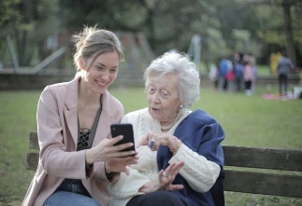

Pastoral Care Volunteers

Wanted

The Role at a Glance:
- Time Commitment: 2 hrs week/fortnight.
- Core Tasks: Listening, talking, and building genuine connections.
- Key Benefits: The chance to make a tangible impact on someone's day, while developing skills in a warm and friendly team.

If you want to learn more, join us for Afternoon Tea:
Date | Time | Location
Tuesday  March 17 | 1:30-2.30 PM | Fair Haven  Hervey Bay  Residential Aged Care  (Fraser Island Room)

RSVP: Jackie Crighton (Chaplain)
mob: 0439 250 836
email: jackie.crighton@cofcqld.com.au

Fair Haven Hervey Bay
130 Pantlins Lane, Urraween, Qld, 4655.

