I set out to do Romans 1 and 2 but the sermon ended up an hour long so we are just going to tackle the rest of Romans 1. Welcome to number 2 in our series on Romans.
When I was in high school I was given the task of doing a book review of a novel of our choice; something we had never read before; something we had to borrow from the school library. I wondered the shelves and found a book with a really cool cover. On the cover was a spartan soldier and the novel was set around ancient Greece and in particular the battle of Thermopylae. How cool. No that was dry as dishwater. In fact as the deadline approached I gave the book to my Grandfather who was always reading. In the morning he reported, “that was heavy going.”
Sometimes we can feel something similar about the book of Romans. Sounds cool. But when we start reading we find it difficult; not because it is unimportant or uninteresting but because it is so dense and packed with Holy Spirit inspired intellect of the Apostle Paul; because many of the references are to a particular time in ancient history and the cultural and historical differences to our own time and place and finally because of some translation difficulties; it was written in koine Greek to Latin and Greek speakers and translated into English.
^{Chapter 1} Paul longs to see Roman Christians
⁸ Let me say first that I thank my God for all of you, through Jesus the king, because all the world has heard the news of your faith. ⁹ God is my witness—the God I worship in my spirit in the good news of his son—that I never stop remembering you ¹⁰ in my prayers. I ask God again and again that somehow at last I may now be able, in his good purposes, to come to you. ¹¹ I’m longing to see you! I want to share with you some spiritual blessing to give you strength; ¹² that is, I want to encourage you, and be encouraged by you, in the faith you and I share. ¹³ I don’t want you to be unaware, my dear family, that I’ve often made plans to come to you; it’s just that up to now something has always got in the way. I want to bear some fruit among you, as I have been doing among the other nations.

Good news, salvation and the justice of God
¹⁴ I am under obligation to Greeks and barbarians alike, you see; both to the wise and to the foolish. ¹⁵ That’s why I’m eager to announce the good news to you, too, in Rome. ¹⁶ I’m not ashamed of the good news; it’s God’s power, bringing salvation to everyone who believes—to the Jew first, and also, equally, to the Greek. ¹⁷ This is because God’s covenant justice is unveiled in it, from faithfulness to faithfulness. As it says in the Bible, “the just shall live by faith.”
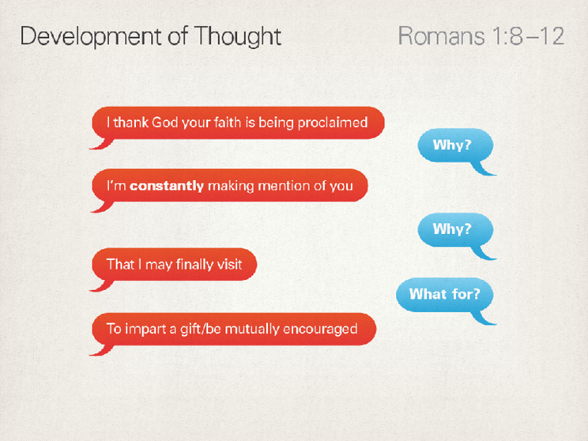

Paul wants to visit the church in Rome; a small group of Jews and gentiles meeting in a few homes (as we shall see in chapter 16). They would have been the poor people who lived on the river where it floods rather than the rich people who lived in the hills. Paul seems to know and even be related to some of them and wants to visit to encourage and be encouraged. They are doing well. Tradition has it the Peter planted this church some years before.

But there may also be some tension among them that Paul is attempting to cautiously address. Nero is the emperor at the time of writing but 6 or 8 years earlier Claudius had been emperor and there had been some trouble for the Jews. Possibly conflict over the coming of the gospel there had been some trouble between followers of the Way of Jesus and Judaisers and Claudius had kicked them all out of the city. This new Jewish sect was even stranger than the last making some Jews angry. Be gone all of you.

The gentile church who were left behind in Rome probably just got on with it but it would have been easy to assume, as many have done since that although the Jesus way started in Jerusalem the Jews with all their strange laws and customs, rules and regulations had been left behind. God was doing a new thing. Christianity was for the gentile world. Paul is going to say wait on a minute.

Then the Jews and Jewish Christians came back when the emperor changed. Paul would have known some of them. But within the Jewish believers there was the usual tension. For many of the Jews the law was given to Moses for a reason; how could gentiles just celebrate their freedom from it. For others that law had been fulfilled by the Jewish Messiah and transcended it by including gentiles in his renewed people.

The tension in the cosmopolitan Roman society and between the three groups in the church was real.

Of note here though is the prayer that Paul is praying. He is praying prayers and thanksgiving and blessing and that God would continue to be at work in them. A good prayer if we are to go visit someone.

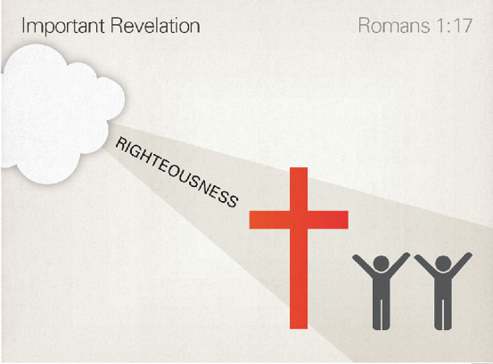
When we get to vs 14-17 it is deep writing. This gospel which he is called to proclaim is for everyone. He doesn’t need to be ashamed of it, because it is God’s power to save people; and it does this by unveiling God’s justice, God’s age-old plan to put the world, and human beings, to rights.
Sometimes we are cowered and ashamed of the gospel in the face of triumphant secularists. For Paul he is writing to a city and a culture dominated by one man; whose decree was law. Maybe Paul had in mind Psalm 119:46: ‘I will speak of your decrees before kings, and I shall not be ashamed.’ That was what he intended to do. ‘At the name of Jesus,’ he wrote in Philippians 2, ‘every knee shall bow’. That included Caesar.
Barbarians were non-Greeks by the way.

Paul has discovered, through years of actually doing it, that when you announce Jesus as the crucified and risen Lord of the world something happens: the new world which was born when Jesus died and rose again comes to fresh life in the hearts, minds and lifestyles of the listeners, or at least some of them. It is God’s power at work, through the faithful announcement of his son. The result is ‘salvation’.

This is such a well-known word that we can easily assume we know what it means and then take it for granted. The meaning we normally assume is ‘going to heaven when we die’. But the New Testament in general, and Paul in particular, have almost nothing to say about that. Yes, of course, they believe that God will rescue all his people from death. Death is a defeated enemy, and its corruption and decay will not have the last word. But this means, not that we’ll all end up in a disembodied heaven, but that God will rescue the entire creation from corruption and decay—and that he will give all his people new bodies, like Jesus’ risen body, to live gloriously within his new world.

That is one of the places the argument of the letter is going, as a glance at chapter 8 will confirm. But this ‘salvation’, as Paul often makes clear, isn’t only in the future, though that’s where its full glory will be seen. It makes its way forwards into the present, rescuing people from the state of sin, and rescuing God’s people from trouble and persecution. ‘Salvation’ is a present reality as well as a future hope. Indeed, when this salvation breaks into someone’s life it becomes an event in itself to which they can then look back in the past. They were saved; they are being saved; they will be saved. This salvation is for everyone who believes. The gospel message—that the crucified and risen Jesus is Lord of the world—needs to be believed. Know it to be true. And those who know it to be true are “in the right” – Justified – righteous.

As we read Romans it is important to understand that Paul uses several words to help articulate a point. Belief and Faith are words that are much bigger than head knowledge and mean a whole of life orientation and action as with justice, justified, righteous and righteousness. In each case it is important to hold all these words and their meanings in mind when you read anyone of them. Salvation is another word that has a bigger meaning than what we have sometimes given it. It is more that just me going to heaven. I am saved, I am being saved, I will be saved from sin and death and judgement and evil; for wholeness, service, love and grace and intimacy.

God’s justice then is his willingness to put the broken and evil world right. And when he does he also puts us in the right and back together. God’s plan for doing this is to make a covenant with one person – Abraham and his family and descendants and then through them to one of his particular descendants Jesus. That’s why N.T Wright in the translation we read called it God’s covenant justice. His plan to put the world and us right.

In Jesus the Messiah, God has shown himself faithful to his covenant purposes and promises, and those who believe the good news about Jesus will find that this faithfulness reaches out and embraces them with a salvation which can never be taken away.

Humans reject God and embrace corruption
¹⁸ For the anger of God is unveiled from heaven against all the ungodliness and injustice performed by people who use injustice to suppress the truth. ¹⁹ What can be known of God, you see, is plain to them, since God has made it plain to them. ²⁰ There are, of course, things about God which you can’t see, namely, his eternal power and deity. But, ever since the world was created, they have been known and seen in the things he has made. As a result, they have no excuse: ²¹ they knew God, but didn’t honour him as God or thank him. Instead, they learned to think in useless ways, and their unwise heart grew dark. ²² They declared themselves to be wise, but in fact they became foolish. ²³ They swapped the glory of the immortal God for the likeness of the image of mortal humans—and of birds, animals and reptiles.
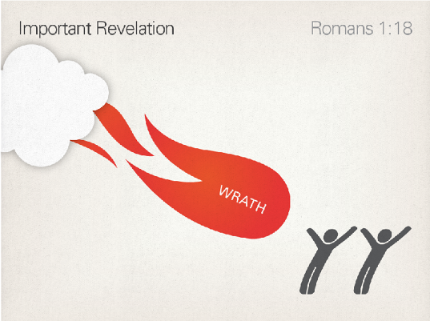
When my parents built their log cabin they had a guy helping them mill timber off the property. He would look at one large tree and say – This is a good one. At another and say “this one is rotten to the core.” If they cut one of those they discovered you could get very little timber from it because the internals were hollow and soft and no good.
Paul here is describing the core rotten nature of this world.
Paul’s explanation for why the gospel, the unveiling of God’s justice and salvation, is urgently required is that the tree is rotten to the core, and might come crashing down at any minute. The tree in question is the human race as it has worked itself into rebellion against its creator at every level. Humans were always designed to be central to God’s plan to rule his creation: that’s part of what it means to be made ‘in God’s image’ (Genesis 1:26–27). So when humans go wrong, the world as a whole is put out of joint. That Paul has this wider salvation in view is clear from the climax in Romans 8. But for now he concentrates on the central feature of the problem: human rebellion. From verse 18 right through to 2:16, he lays out a charge against the human race in general: humankind is rotten at its heart, and the eventual crash to which this will lead (1:32; 2:5; 2:16) is anticipated in the signs of rot and decay which we can see in the branches. (1:24–31). Our present passage, verses 18 to 23, rightly begins with the rotting of the roots themselves. Human beings were made to know, worship, love and serve the creator God.

That’s what means to be fruitful and healthy. But humans often suppress the truth of God’s reign and not give him honour and thanks. When we get to ch4 Paul will refer back to this when he describes how the faith of Abraham and Christians does in fact honour God and give thanks.
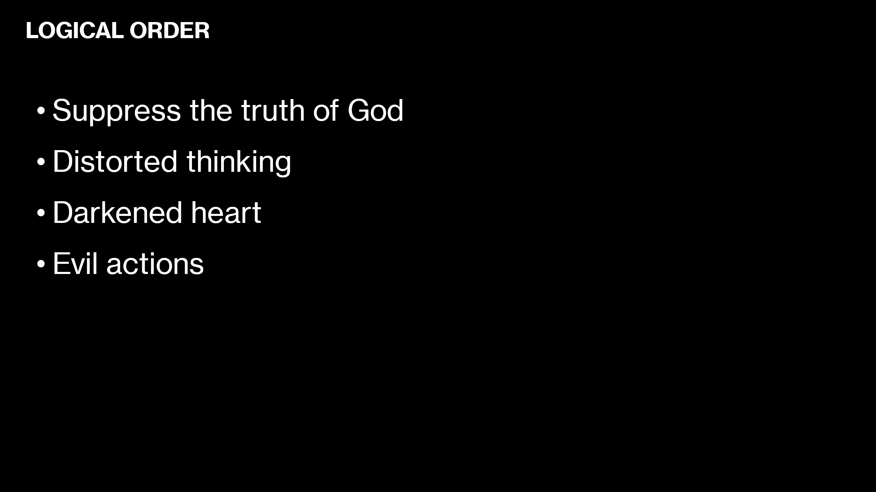
The logic of evil Paul says is failure to worship God; we suppression of the truth of god; distorted thinking; darkened heart; evil actions.

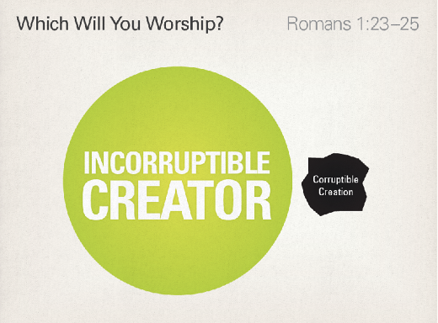
But we are made to worship. In the absence of the true God we will find something to worship. Human form; money power sex idols of all sorts of kinds. When as creatures made in the image of God find something less than God to worship we dehumanise each other because we are made in the image of God. We start to behave in a way that is less truly life giving; a lesser way to be human. Eve in the Garden finds the fruit desirable and will do whatever it takes to get it. Loving things often means using people when we should be loving people and using things.
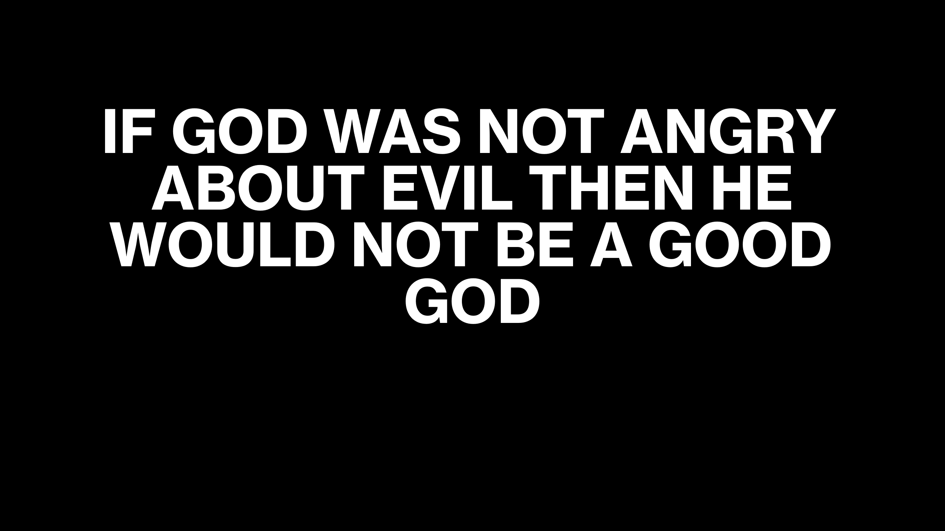
God’s anger or wrath is focussed on the injustice and evil, rape, murder, torture, violence, war, economic oppression etc. and the impact that that has on people. If God was not angry about evil then he would not be a good God.
The tree is indeed dangerously diseased….but God is at work.
Unclean mind, darkened behaviour
²⁴ So God gave them up to uncleanness in the desires of their hearts, with the result that they dishonoured their bodies among themselves. ²⁵ They swapped God’s truth for a lie, and worshiped and served the creature rather than the creator, who is blessed forever, Amen.
²⁶ So God gave them up to shameful desires. Even the women, you see, swapped natural sexual practice for unnatural; ²⁷ and the men, too, abandoned natural sexual relations with women, and were inflamed with their lust for one another. Men performed shameless acts with men, and received in themselves the appropriate repayment for their mistaken ways.

Darkened mind, darkened behaviour
²⁸ Moreover, just as they did not see fit to hold on to knowledge of God, God gave them up to an unfit mind, so that they would behave inappropriately. ²⁹ They were filled with all kinds of injustice, wickedness, greed and evil; they were full of envy, murder, enmity, deceit and cunning. They became gossips, ³⁰ slanderers, God-haters, arrogant, self-important, boastful, inventors of evil, disobedient to parents, ³¹ unwise, unfaithful, unfeeling, uncaring. ³² They know that God has rightly decreed that people who do things like that deserve death. But not only do they do them; they give their approval to people who practice them.

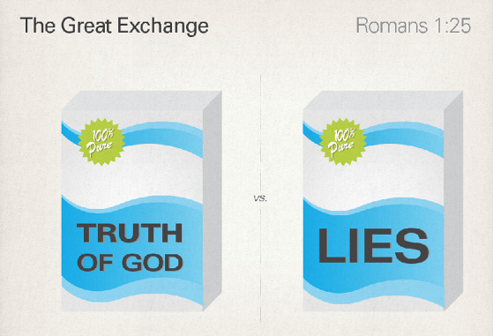

So we return to two themes:
- Is the tension in the church. It is quite possible that some. Probably gentile believers were behaving and teaching that freedom in Christ meant living however you wanted. Jude writes about people who were teaching others they could sin; going the way of Cain and fallen angels polluting your love feasts and simply looking after their own needs. This is possibly why there were Judiasers demanding people be circumcised and follow the law. Paul addresses this problem later and more directly in other letters.
- The second is the main point that the gospel is good news because of the broken state of the human race. The human race had swapped the truth for a lie.

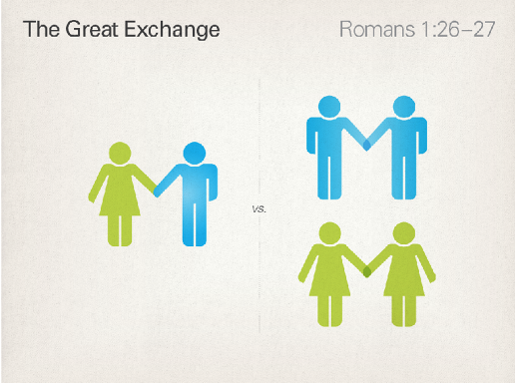

Paul’s first example here of this human brokenness is same sex practices before listing a whole bunch of others.

The thing about Rome is that everyone was doing this. Sexual promiscuousness had reached new heights under Nero. Nero commanded drunken sex orgies and for one night a slave could take his masters wife to bed. We know a great deal about the sexual practises of the Romans because of the writing of Suetonius; Martial, Catullus; and Ovid – Roman historians and poets.

A Roman man had a prostitute for pleasure; a concubine for prestige and a wife for children. The prostitute could be male or female. The normal pagan idolatrous practices were exploitative in nature men using boys and slaves etc.

All sorts of same sex practices were common in the ancient world. Nero married a boy dressed up as a girl.

No one thought of themselves as homosexual. That term and the associated theory of same sex attraction was not invented until 1890’s. The RSV was the first to use the term homosexual in 1946. A conservative evangelical pastor wrote to them in the in 1959 saying he was concerned that using this word may mean that some people could show prejudice against a vulnerable minority. The translation review committee didn’t meet again until 1966 but when they deliberated they agreed that the term was not a good translation but they didn’t have another edition printed until 1971. In the mean time various other translations like the Living Translation was printed using the RSV as the basis of their translation and the word and associated meaning was repeated.

Paul is not saying there are some really deviant people called homosexuals who experience same sex attraction. Homosexuality does not condemn you any more than heterosexuality saves you.

I think that there is a bigger point to be made. It is not about individuals who have same sex attraction. He is suggesting that the fact that there are such practices is a corruption of the created male/female order. It is a sign, being lived out in humans of the rot at its core, that the whole world is out of joint. He could have used murder or theft as examples and he does make a long list.

For Paul this is just natural outcome that following your lusts leads you to. Just like Adam and Eve in the garden once you start lusting over the things of this world it leads to start believing your own wisdom, the voice of the creature not the creator.

God gave them up. In other words allowed them to make choices that have consequences. Not just as individuals but human kind as a whole. He is using this as an example not chastising a particular group of people as particularly evil. Many shallow and unhelpful readings have done great damage in what is already a difficult conversation.

He will make this point in chapter 4 that faith of Abraham and Christians undoes the corruption but if we choose to continue in our idolatry we will start to resemble the very thing we worship. When we worship something less than human we undo our humanity bit by bit.

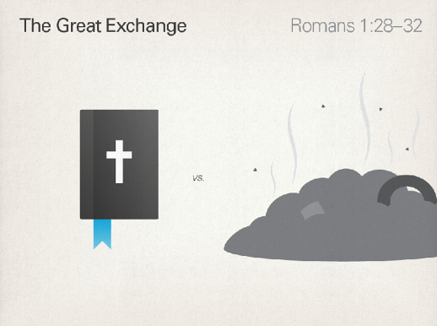

God gave them over. God let them have there way. If we consider how it would be like living with people like this then I think we would agree that it would be awful. A living hell. He gave them up to an unfit mind. Evil is what you get when the mind is twisted out of shape and the body goes along for the ride.

But when we start approving of evil and saying it is good. That’s even worse than doing something bad and regretting it. God has made the world in such a way that kindness, gentleness, generosity, humility—love in all its many forms—is life-giving, while evil in its many forms is deadly.

First let us think of the problem and solution in the broader picture. The Gospel: King Jesus in His death and resurrection has overcome evil powers; sin and death. The church is the plant at the centre of the corrupted and rotten world through which God’s righteous rule of love and grace and wholeness is to be expressed and through which the healing of the world will come.

That’s exciting that’s worth proclaiming and celebrating. Hallelujah! I am not ashamed of the gospel of Jesus Christ.

The second thing to reflect on is: What is the thinking that leads me to be tempted to revert to sin as a way of meeting my deepest needs?

